Compiler : Eclipse

OS : windows 7

These codes have implemented these three function group by with having, in and join.

The query for each function is:

Group by with having: select count(\*),address from student group by address having count(\*)>1;

In: select ID,NAME from student where NAME IN(select NAME from student where ADDRESS = PS and MAJOR = CS);

Natural Join: select ID,NAME,ADDRESS,MAJOR,DEPT from student,major where student.MAJOR = major.MAJOR

Please run this code by following steps below:

1. Open eclipse and create a project.
2. Create package named lms.hw and drag java files into the package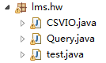.
3. Put csv data files into D:/.
4. Run test.java.

The data in csv file:

Student.csv:

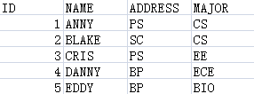

Major.csv:

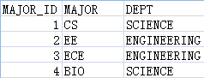

The expected result:

You will find three csv files in D:/



The result in each csv file is:

:









